Abstract

Heart disease prediction models commonly depend on conventional clinical and demographic variables such as age, blood pressure, diabetes, cholesterol and lifestyle-related factors. Although these variables are useful for risk prediction, the use of urine-based biomarkers has received comparatively less attention, despite their relevance to kidney and cardiovascular health. This study proposes a machine learning and deep learning approach for heart disease risk detection using urine as a biological fluid. Two synthetic datasets, each containing 50,000 patient records, were generated through mechanistic and probabilistic approaches. The datasets incorporated urine biomarkers including urine albumin, UACR, KIM-1 and NGAL, along with demographic, clinical and other urine-related features. The proposed workflow included data validation, preprocessing, normalization, stratified train-validation-test splitting and model development using LightGBM, XGBoost, Random Forest, CRF, 1-D CNN and Weighted Mean Swarm MLP. Model performance was assessed using accuracy, precision, recall, F1-score and confusion matrices. The mechanistic dataset produced considerably stronger results, with LightGBM recording the highest accuracy of 98.47%. In comparison, the probabilistic dataset was more challenging, with 1-D CNN obtaining the highest accuracy of 80.91%. These findings indicate the potential of urine-based features for computational heart disease risk modelling. Future work will involve testing the proposed approach with real clinical urine samples and larger heterogeneous datasets.
1. Introduction

Heart disease continues to be a significant health concern worldwide, making early identification of individuals at risk an important area of research. Many existing machine learning approaches for heart disease prediction use variables such as age, blood pressure, diabetes, cholesterol, body mass index and smoking status. While these models have shown promising predictive results, they mainly depend on conventional clinical and demographic information and give limited attention to biological fluids such as urine. The relatively small size of datasets used in several existing studies can also affect the generalizability of the resulting models.

This study explores the use of urine as a biological fluid for heart disease risk detection. Urine can be collected non-invasively and contains biomarkers associated with kidney function, inflammation and cardiovascular health. The proposed approach gives particular importance to urine albumin, urine albumin-to-creatinine ratio (UACR), kidney injury molecule-1 (KIM-1) and neutrophil gelatinase-associated lipocalin (NGAL). These biomarkers are considered together with demographic, clinical and additional urine-related characteristics to develop a computational framework for heart disease risk prediction.

Two synthetic datasets, each consisting of 50,000 patient records, are used to develop and evaluate the proposed approach. One dataset is generated using a mechanistic approach, while the other uses a probabilistic approach. Before model training, the datasets are examined for missing values, duplicate records and inconsistencies. Categorical variables are encoded, while numerical variables undergo scaling and normalization. The resulting data are divided into training, validation and testing subsets in a 70:15:15 ratio. Six models, namely LightGBM, XGBoost, Random Forest, CRF, 1-D CNN and Weighted Mean Swarm MLP, are trained and evaluated using accuracy, precision, recall and F1-score.
The results show a clear difference between the two synthetic data generation approaches. The models performed considerably better on the mechanistic dataset, where LightGBM obtained the highest accuracy of 98.47%. For the probabilistic dataset, 1-D CNN produced the highest accuracy at 80.91%. These results suggest that the proposed urine-based feature framework can generate useful computational signals for heart disease risk modelling, while also demonstrating that the method used to generate synthetic data can influence model performance.

2. Literature Review

Park et al. [1] examined the relationship between urinary kidney injury biomarkers and cardiovascular outcomes using data from the Chronic Renal Insufficiency Cohort study. The researchers considered biomarkers such as KIM-1 and NGAL in relation to cardiovascular disease events and mortality. The analysis used statistical survival methods rather than machine learning, leaving scope for computational prediction using these biomarkers.

Liu et al. [2] investigated the association between urinary NGAL and cardiovascular disease and mortality in patients with chronic kidney disease. Their findings indicated that urinary NGAL could provide information relevant to cardiovascular risk. The study mainly focused on statistical relationships and did not develop a machine learning model for heart disease prediction.

Kirbiš et al. [3] studied urinary NGAL in patients experiencing ST-elevation myocardial infarction and acute heart failure. The study was conducted using a relatively small patient population and showed limited predictive discrimination. Although the findings support the relevance of NGAL in cardiovascular research, the limited sample size and lack of a universally validated threshold point to the need for larger computational investigations.

Akella and Akella [4] assessed multiple machine learning algorithms for coronary artery disease prediction using the Cleveland heart disease dataset. Artificial neural networks showed strong predictive performance in their experiments. A limitation is that the study used a relatively small conventional clinical dataset and did not include urine biomarkers in the modelling process.

Bharti et al. [5] developed a heart disease prediction approach combining machine learning and deep learning methods using the UCI heart disease dataset. Their deep learning model produced promising results. The work primarily relied on conventional clinical attributes and did not explore urine-based biomarkers as part of the prediction framework.

Louridi et al. [6] explored machine learning techniques for identifying cardiovascular defects using the UCI Heart Disease and Framingham datasets. The study compared different classification methods, with ensemble techniques producing strong results. Despite this, the work focused on conventional clinical variables and did not include urinary biomarkers such as albumin, KIM-1 or NGAL.

Cho et al. [7] compared traditional cardiovascular risk prediction approaches with machine learning-based methods using a large Korean population dataset. Their results showed that machine learning techniques could improve cardiovascular risk prediction when applied to large-scale datasets. However, the models primarily used conventional health and demographic variables and did not incorporate urine biomarkers.

Ehsan et al. [8] investigated urinary NGAL as a possible biomarker for vascular complications and risk stratification in patients with peripheral arterial disease. The study found an association between urinary NGAL and vascular outcomes. However, its patient population was relatively small, and the work did not combine NGAL with multiple urinary biomarkers in a machine learning framework for heart disease prediction.

Maini et al. [9] developed a machine learning-based heart disease prediction system using medical records from an Indian population. Random Forest achieved high predictive accuracy in their experiments. Although the study is relevant to heart disease prediction in an Indian population, its models mainly relied on conventional medical features and did not consider urine-based biomarkers.

Research Gap and Novelty

Overall, the reviewed studies show that urinary biomarkers such as albumin, KIM-1 and NGAL are relevant to kidney and cardiovascular conditions, while other studies have demonstrated the usefulness of machine learning and deep learning for cardiovascular risk prediction. However, these two areas have largely been explored independently. To address this gap, the present study combines urine-based biomarkers, specifically urine albumin, UACR, KIM-1 and NGAL, with machine learning and deep learning models for computational heart disease risk detection. In addition, two synthetic data generation strategies, mechanistic and probabilistic, are evaluated using datasets containing 50,000 records each. The study further introduces a Weighted Mean Swarm MLP to investigate distributed model training through parameter aggregation across simulated nodes.

3. Proposed Methodology

The methodology combines urine-based biomarkers with demographic, clinical and additional urine-related features to detect heart disease risk. Two synthetic datasets, each containing 50,000 records, are used for the study. These datasets are produced using two different generation strategies: mechanistic and probabilistic data generation.

In the mechanistic approach, patient records are generated using predefined relationships between clinical characteristics, urine biomarkers and heart disease risk. In contrast, the probabilistic approach introduces probabilistic variations among the features and target variable, resulting in a dataset with a more challenging prediction environment. This allows the models to be evaluated under two different synthetic data conditions.
Following dataset generation, the records are validated to identify missing values, duplicate entries and possible inconsistencies. During preprocessing, missing values are handled where necessary, categorical variables are encoded, and numerical variables are subjected to feature scaling and normalization. The processed datasets are subsequently divided into training, validation and testing subsets using a ratio of 70%, 15% and 15%, respectively.

Six models are used for prediction: LightGBM, XGBoost, Random Forest, CRF, 1-D CNN and Weighted Mean Swarm MLP. LightGBM, XGBoost and Random Forest are tree-based machine learning algorithms, while CRF is used for sequence-based classification and 1-D CNN represents a deep learning approach. In addition, a Weighted Mean Swarm MLP is used to introduce a distributed learning approach. The training data is divided among five simulated nodes, where each node trains an MLP model using its local data. The parameters from the local models are then combined using weighted mean aggregation to obtain the final Swarm MLP model. The aggregated model is then used to generate predictions on the test dataset. All models are evaluated using accuracy, precision, recall, F1-score and confusion matrix, and their performance is compared.

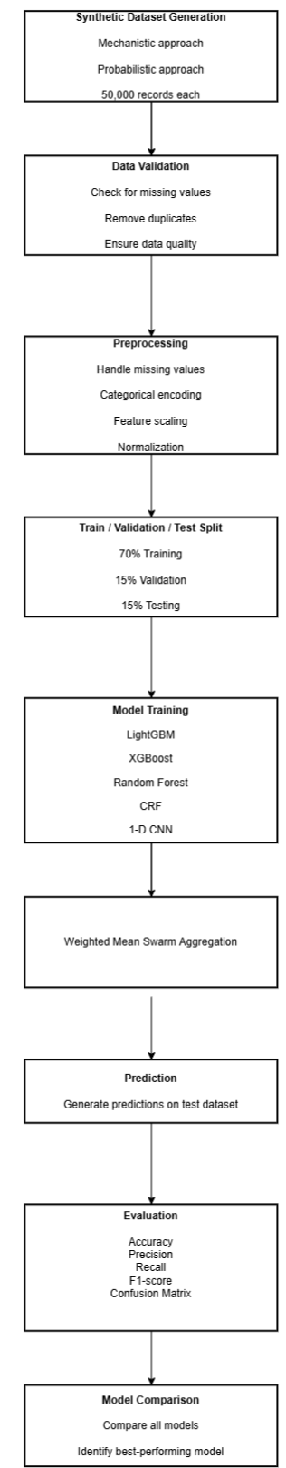

Figure 1: Proposed Methodology / Model Workflow

Figure 1 presents the overall workflow of the proposed approach, starting from synthetic dataset generation and data validation and continuing through preprocessing, data splitting and model training. The trained models are then used in the Weighted Mean Swarm Aggregation step, where model parameters from the five simulated nodes are combined using weighted mean aggregation. The aggregated model generates predictions that are evaluated using standard classification metrics and confusion matrices, followed by comparison of their performance.

Table 1: Dataset Features and Biological Fluid Methodology

Feature/Biomarker | Description | Role in Model
Urine Albumin | Protein in urine | Key urine biomarker
UACR | Urinary albumin-to-creatinine ratio | Normalizes urinary albumin
KIM-1 | Kidney injury molecule-1 | Urine biomarker of kidney injury
NGAL | Neutrophil gelatinase-associated lipocalin | Urine biomarker of kidney injury
Age | Patient age (years) | Demographic feature
Gender | Male/Female | Demographic feature
BMI | Body mass index (kg/m²) | Clinical risk factor
Systolic Blood Pressure | Systolic blood pressure (mmHg) | Cardiovascular risk factor
Diastolic Blood Pressure | Diastolic blood pressure (mmHg) | Cardiovascular risk factor
Diabetes | 0/1 (Yes/No) | Comorbidity
Smoking | 0/1 (Yes/No) | Lifestyle risk factor
Physical Activity | Activity level | Lifestyle feature
Family History | Family history of heart disease | Risk factor
Resting Heart Rate | Resting heart rate (bpm) | Cardiovascular feature
Urine Creatinine | Urinary creatinine level | Used with albumin for UACR
Urine Total Protein | Total protein in urine | Kidney-related feature
Urine Glucose | Glucose level in urine | Additional urine feature
Specific Gravity | Urine concentration | Additional urine feature
Urine pH | Acidity/alkalinity of urine | Additional urine feature
Sodium | Urinary sodium level | Additional urine feature
Potassium | Urinary potassium level | Additional urine feature
Blood | Blood detected in urine | Additional urine feature
Ketones | Ketones detected in urine | Additional urine feature
Albuminuria Category | Category based on urinary albumin | Kidney-related feature

Table 1 summarizes the main features used in the proposed framework, with particular emphasis on urine-based biomarkers. Urine albumin, UACR, KIM-1 and NGAL form the core biological-fluid features, while demographic, clinical and additional urine-related variables provide supporting information for model development.
Urine is chosen as the biological fluid because it is non-invasive, easy to collect, cost-effective and contains important biomarkers related to kidney and cardiovascular health [1]–[3].

4. Results and Discussion

The confusion matrices further illustrate the classification performance of the evaluated models. The Weighted Mean Swarm MLP produced 4,131 true negatives, 212 false positives, 848 false negatives and 2,309 true positives for the mechanistic dataset. For the probabilistic dataset, it produced 5,054 true negatives, 251 false positives, 1,454 false negatives and 741 true positives. These results show that the Swarm MLP was able to distinguish between the low- and high-risk classes while demonstrating the feasibility of parameter aggregation across simulated distributed nodes.

Table 2: Performance Comparison of Machine Learning and Deep Learning Models

Model | Type | Mechanistic Accuracy (%) | Mechanistic Precision (%) | Mechanistic Recall (%) | Mechanistic F1-score (%) | Probabilistic Accuracy (%) | Probabilistic Precision (%) | Probabilistic Recall (%) | Probabilistic F1-score (%)
LightGBM | Machine Learning | 98.47 | 97.56 | 98.83 | 98.19 | 78.29 | 60.43 | 74.81 | 66.86
XGBoost | Machine Learning | 98.41 | 97.65 | 98.61 | 98.12 | 78.43 | 60.88 | 73.53 | 66.61
Random Forest | Machine Learning | 96.37 | 95.29 | 96.14 | 95.71 | 80.21 | 65.95 | 66.97 | 66.46
CRF | Machine Learning | 92.09 | 90.96 | 90.18 | 90.57 | 77.53 | 63.45 | 54.81 | 58.81
1-D CNN | Deep Learning | 98.08 | 98.77 | 96.64 | 97.69 | 80.91 | 71.59 | 57.63 | 63.86
Weighted Mean Swarm MLP | Deep  Learning | 85.87 | 91.59 | 73.14 | 81.33 | 77.27 | 74.70 | 33.76 | 46.50

Table 2 separates the evaluated approaches into machine learning and deep learning models while presenting their performance on both synthetic datasets. The mechanistic dataset shows higher performance across the models, with LightGBM achieving the highest accuracy, whereas 1-D CNN performs best on the probabilistic dataset.

The Weighted Mean Swarm MLP achieved an accuracy of 85.87% on the mechanistic dataset and 77.27% on the probabilistic dataset. Although its performance was lower than the individual models, the results demonstrate the application of distributed model training with weighted parameter aggregation in the proposed approach.

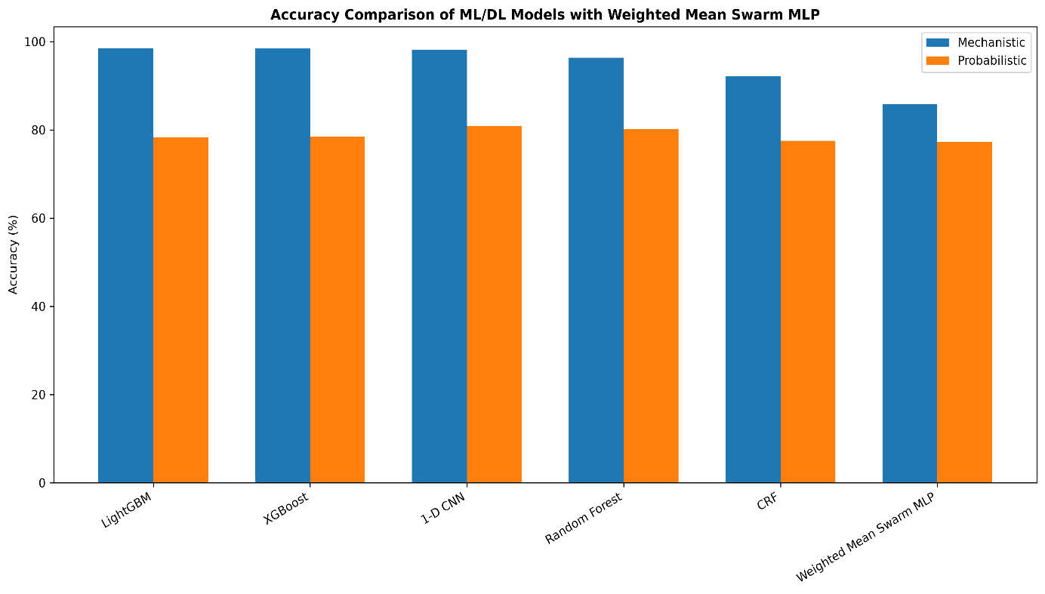

Figure 2: Accuracy comparison of the six evaluated models on mechanistic and probabilistic datasets.

Figure 2 presents the accuracy comparison of the six evaluated models across the mechanistic and probabilistic datasets. The results show that the conventional machine learning and deep learning models achieved higher accuracy on the mechanistic dataset, while the Weighted Mean Swarm MLP showed comparatively lower accuracy on both datasets.
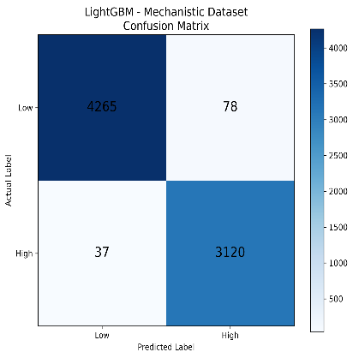 | 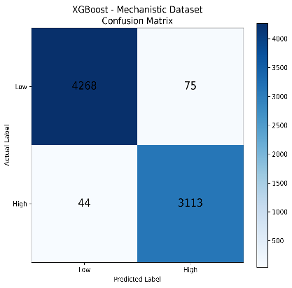 | 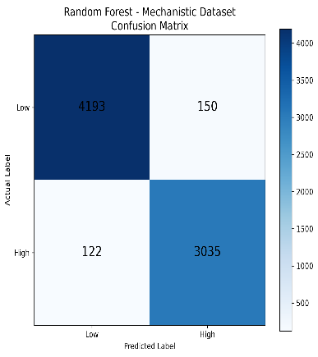
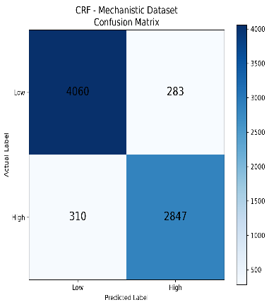 | 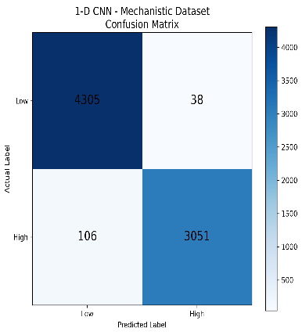 | 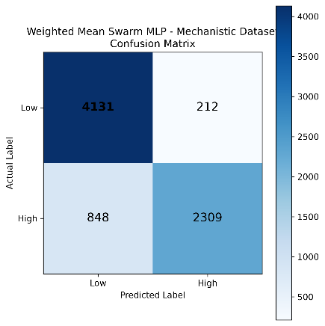
Figure 3: Confusion Matrices for Models on the Mechanistic Dataset

Figure 3 shows the confusion matrices obtained for the six evaluated models on the mechanistic dataset.

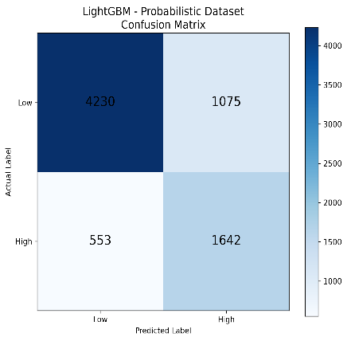 | 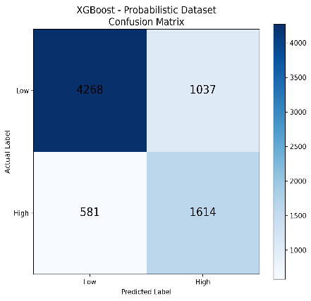 | 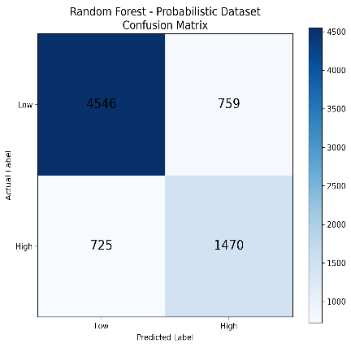
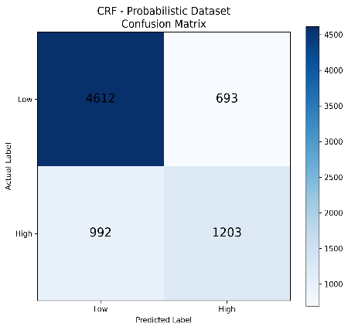 | 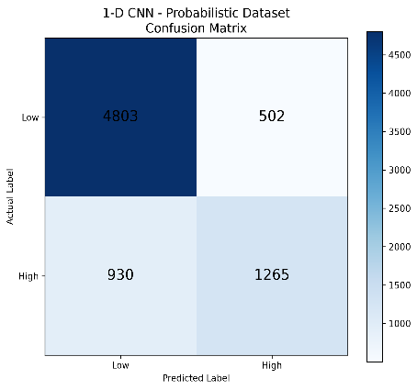 | 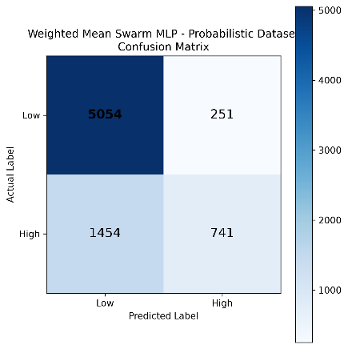

Figure 4: Confusion Matrices for Models on the Probabilistic Dataset

Figure 4 presents the confusion matrices obtained for the six evaluated models on the probabilistic dataset. Compared with the mechanistic dataset, the probabilistic dataset shows greater variation in classification performance, which is reflected in the model evaluation results.

The results demonstrate that LightGBM provided the strongest performance among the original models on the mechanistic dataset, reaching an accuracy of 98.47%. XGBoost followed closely with an accuracy of 98.41%, while 1-D CNN and Random Forest achieved 98.08% and 96.37%, respectively. On the probabilistic dataset, 1-D CNN obtained the highest accuracy among the original models at 80.91%. The Weighted Mean Swarm MLP achieved an accuracy of 77.27% on the probabilistic dataset, demonstrating the application of distributed model training with weighted parameter aggregation.

5. Conclusion

This study presented a machine learning and deep learning framework for heart disease risk detection using urine as a biological fluid. The proposed approach incorporated urine albumin, UACR, KIM-1 and NGAL along with demographic, clinical and other urine-related features. Two synthetic datasets containing 50,000 records each were generated using mechanistic and probabilistic approaches and processed through data validation, preprocessing, and a 70:15:15 train-validation-test split. Six models, namely LightGBM, XGBoost, Random Forest, CRF, 1-D CNN and Weighted Mean Swarm MLP, were evaluated using accuracy, precision, recall and F1-score. The mechanistic dataset produced substantially stronger results across the evaluated models, with LightGBM achieving the highest accuracy of 98.47%, while 1-D CNN achieved the highest accuracy of 80.91% on the probabilistic dataset. The results demonstrate that the framework can identify patterns within synthetic urine-based features for computational heart disease risk modelling. Among the evaluated approaches, the tree-based machine learning models performed particularly well on the mechanistic dataset, while the 1-D CNN provided the strongest accuracy on the probabilistic dataset. These findings support the potential of combining urine-based biomarkers with machine learning and deep learning techniques for computational modelling of heart disease risk. However, since the datasets used in this study are synthetic, the reported results should not be interpreted as clinical diagnostic performance or evidence of direct clinical applicability. The study is intended as a computational framework and requires validation using real-world clinical data before medical conclusions can be drawn. Future work should therefore focus on evaluating the proposed framework using real clinical urine samples, larger and more diverse patient populations, and confirmed cardiovascular outcomes. Further investigation can also include additional urinary biomarkers, explainable artificial intelligence methods, improved feature selection techniques, and external validation across independent datasets. Such validation would help determine whether the patterns identified in synthetic data are reproducible in real clinical settings and whether urine-based measurements can provide useful complementary information for heart disease risk assessment. Overall, the study demonstrates a structured approach for investigating urine-based biomarkers through computational methods while highlighting the need for clinical validation and further research before practical diagnostic use.

References

[1] J. Park et al., “Urine Kidney Injury Biomarkers and Risks of Cardiovascular Disease Events and All-Cause Death: The CRIC Study,” Clinical Journal of the American Society of Nephrology, 2017.

[2] K. D. Liu et al., “Urine Neutrophil Gelatinase-Associated Lipocalin and Risk of Cardiovascular Disease and Death in CKD: Results From the Chronic Renal Insufficiency Cohort (CRIC) Study,” American Journal of Kidney Diseases, 2015.

[3] M. Kirbiš et al., “The role of urine neutrophil gelatinase-associated lipocalin (NGAL) in acute heart failure in patients with ST-elevation myocardial infarction,” BMC Cardiovascular Disorders, 2015.

[4] S. Akella and R. Akella, “Machine learning algorithms for predicting coronary artery disease: efforts toward an open source solution,” Future Science OA, 2021.

[5] S. Bharti et al., “Prediction of Heart Disease Using a Combination of Machine Learning and Deep Learning,” Computational Intelligence and Neuroscience, 2021.

[6] M. Louridi et al., “Machine learning-based identification of patients with a cardiovascular defect,” Journal of Big Data, 2021.

[7] J. Cho et al., “Pre-existing and machine learning-based models for cardiovascular risk prediction,” Scientific Reports, 2021.

[8] H. Ehsan et al., “Urinary neutrophil gelatinase-associated lipocalin (NGAL) can potentially predict vascular complications and reliably risk stratify patients with peripheral arterial disease,” Scientific Reports, 2022.

[9] S. Maini et al., “Machine learning-based heart disease prediction system for Indian population: An exploratory study done in South India,” Medical Journal Armed Forces India, 2021.

